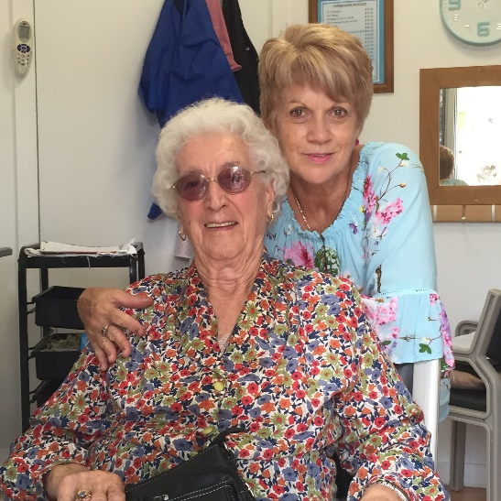

We are seeking an appropriately skilled hairdresser who is passionate about making people who are elderly and adults with a range of abilities look and feel their best. An opportunity exists under a contractor arrangement to use our small one chair salon at our centre in Nerang and manage your own clients.
Our organisation supports people to Love Life and Live Well. We operate group social programs at our centre Monday – Friday and offer home based individual support services to keep people living independently and socially connected. Liberty is values driven and approaches service delivery using a Wellbeing Experience of Connection, Individuality, Vibrancy, Accomplishment, Purpose and Satisfaction. To find out more about our organisation and how we support our community head to our website at www.libertycommunity.org.au.
A successful contract arrangement will require :
- Appropriate hairdressing qualifications.
- An NDIS Worker Clearance (or obtain prior to commencement).
- Required number of Covid-19 Vaccination doses.
- Australian Business Number.
- Appropriate business insurances.
- Maintenance of Safety Data Sheets for products used in salon.
- Have physical capacity to perform the duties as required.
If you are interested in this opportunity please email rachelle@libertycommunity.org.au or phone Rachelle Montgomery on 07 5578 1668

